**Exercise 1: Implementing the Singleton Pattern**

**Scenario:**

You need to ensure that a logging utility class in your application has only one instance throughout the application lifecycle to ensure consistent logging.

**Steps:**

1. **Create a New Java Project:**
   * Create a new Java project named **SingletonPatternExample**.
2. **Define a Singleton Class:**
   * Create a class named Logger that has a private static instance of itself.
   * Ensure the constructor of Logger is private.
   * Provide a public static method to get the instance of the Logger class.
3. **Implement the Singleton Pattern:**
   * Write code to ensure that the Logger class follows the Singleton design pattern.
4. **Test the Singleton Implementation:**
   * Create a test class to verify that only one instance of Logger is created and used across the application

**SOLUTION**

**CODE:**

**public class Logger {**

**private static Logger *instance*;**

**private Logger() {**

**System.*out*.println("Logger initialized.");**

**}**

**public static Logger getInstance() {**

**if (*instance* == null) {**

***instance* = new Logger();**

**}**

**return *instance*;**

**}**

**public void log(String message) {**

**System.*out*.println("Log: " + message);**

**}**

**}**

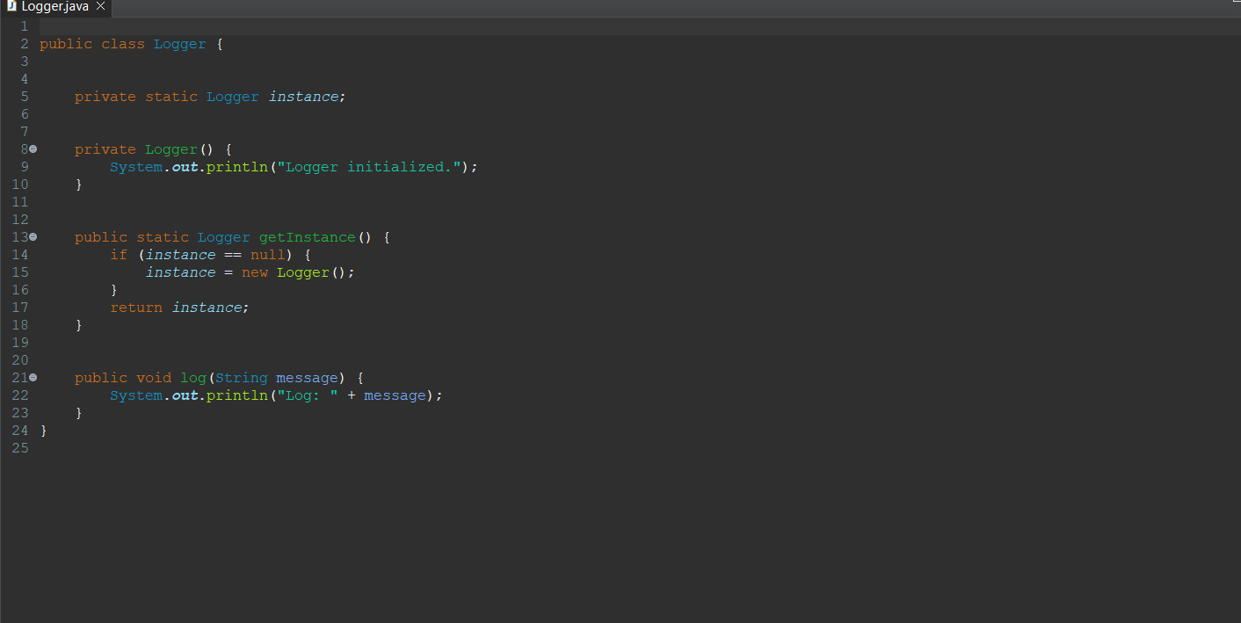

**// Main.java**

**public class Main {**

**public static void main(String[] args) {**

**// Getting logger instance 1**

**Logger logger1 = Logger.*getInstance*();**

**logger1.log("First log message");**

**// Getting logger instance 2**

**Logger logger2 = Logger.*getInstance*();**

**logger2.log("Second log message");**

**// Testing if both instances are the same**

**if (logger1 == logger2) {**

**System.*out*.println("Both logger instances are the same (Singleton works).");**

**} else {**

**System.*out*.println("Different logger instances (Singleton failed).");**

**}**

**}**

**}**

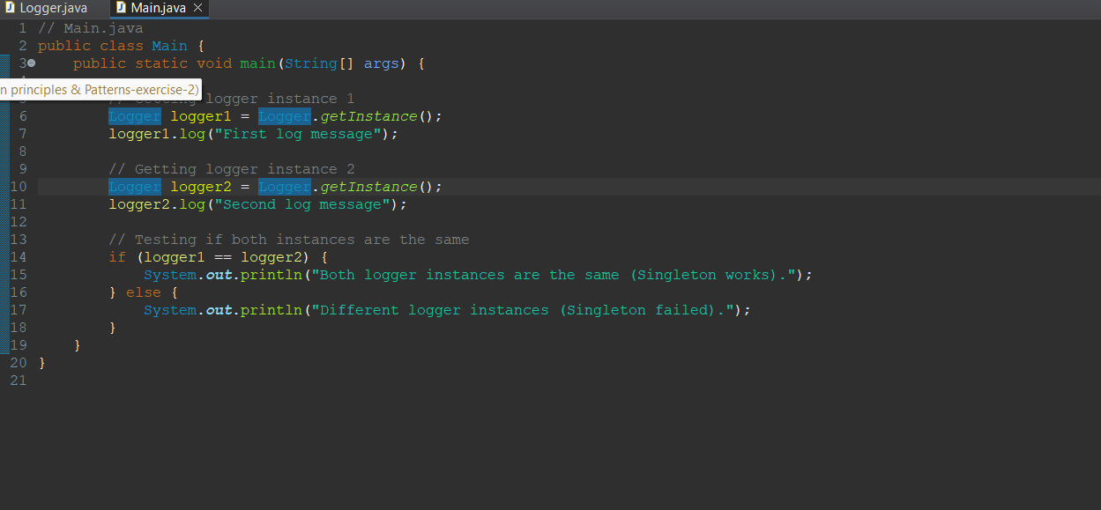

**OUTPUT:**

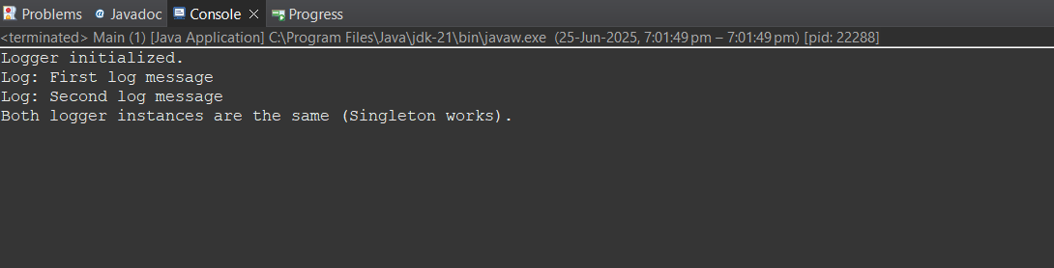

**Exercise 2: Implementing the Factory Method Pattern**

**Scenario:**

You are developing a document management system that needs to create different types of documents (e.g., Word, PDF, Excel). Use the Factory Method Pattern to achieve this.

**Steps:**

1. **Create a New Java Project:**
   * Create a new Java project named **FactoryMethodPatternExample**.
2. **Define Document Classes:**
   * Create interfaces or abstract classes for different document types such as **WordDocument**, **PdfDocument**, and **ExcelDocument**.
3. **Create Concrete Document Classes:**
   * Implement concrete classes for each document type that implements or extends the above interfaces or abstract classes.
4. **Implement the Factory Method:**
   * Create an abstract class **DocumentFactory** with a method **createDocument()**.
   * Create concrete factory classes for each document type that extends DocumentFactory and implements the **createDocument()** method.
5. **Test the Factory Method Implementation:**
   * Create a test class to demonstrate the creation of different document types using the factory method.

**SOLUTION:**

**CODE:**

**package documents;**

**public interface Document {**

**void open();**

**}**

**package documents;**

**public abstract class DocumentFactory {**

**public abstract Document createDocument();**

**}**

**package documents;**

**public class ExcelDocument implements Document {**

**public void open() {**

**System.*out*.println("Opening Excel document.");**

**}**

**}**

**package documents;**

**public class ExcelDocumentFactory extends DocumentFactory {**

***@Override***

**public Document createDocument() {**

**return new ExcelDocument();**

**}**

**}**

**package documents;**

**public class PdfDocument implements Document {**

**public void open() {**

**System.*out*.println("Opening PDF document.");**

**}**

**}**

**package documents;**

**public class PdfDocumentFactory extends DocumentFactory {**

***@Override***

**public Document createDocument() {**

**return new PdfDocument();**

**}}**

**package documents;**

**public class WordDocument implements Document {**

**public void open() {**

**System.*out*.println("Opening Word document.");**

**}**

**}**

**package documents;**

**public class WordDocumentFactory extends DocumentFactory {**

***@Override***

**public Document createDocument() {**

**return new WordDocument();**

**}**

**}**

**OUTPUT:**

